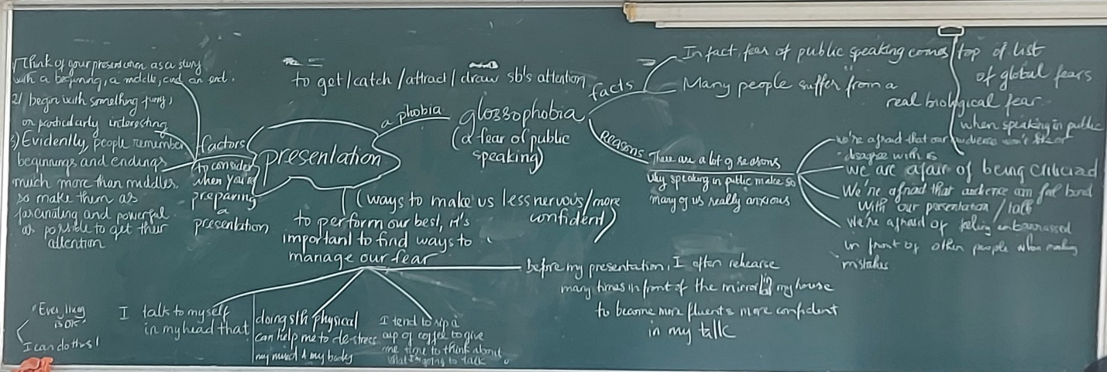

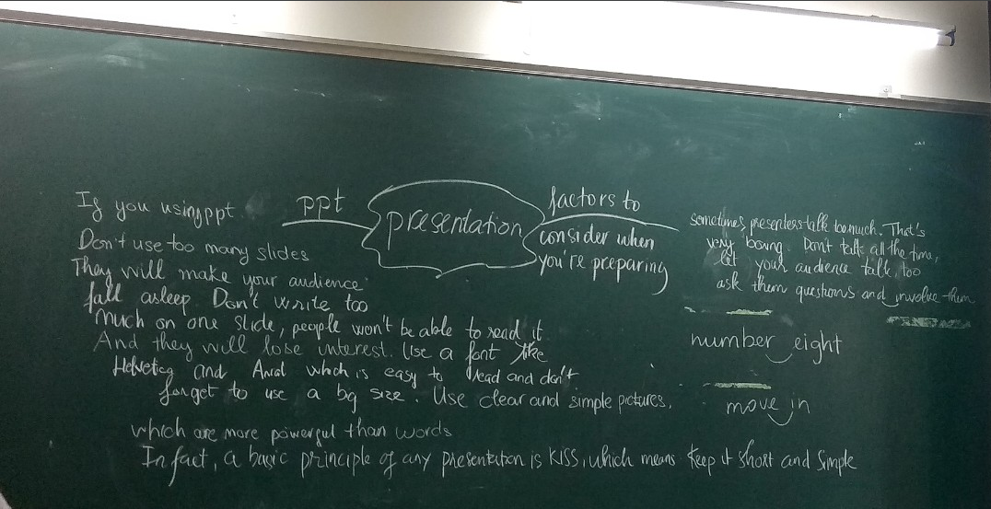

TOPIC: PRESENTATION

Questions:

1. Do you like giving presentations?
2. Why do some people feel nervous about giving presentations?
3. What do you usually do to make you more confident before giving a presentation? /To perform your best, what do you usually do to manage your fear of public speaking?
4. What do you think people should do before giving a presentation?
5. How can visual aids help in a presentation?
6. How can people improve their public speaking skills?

Hiển’s:

I can speak in front of other people naturally without any fear of public speaking. But, in some situations, when I talk sth wrongly, I have the ability to turn the tables on my mistakes by turning them into funny sayings and jokes.

Hoàng Anh:

Do you like giving presentations?

* No, I don’t like public speaking / delivering a speech because I have a phobia about speaking in front of other people. I’m afraid of being criticized when making mistakes.

Phuoc’s:

No, I don’t like public speaking because I’m a good listener and I prefer to be an audience to a presenter. Moreover, I like answering thought-provoking questions.

Duyên’s:

Do you like giving presentations?

* Yes, certainly / absolutely. Although giving presentation sometimes can make me feel a little bit nervous, I still like speaking in front of other people because it’s a good chance to convey / to express my perspectives, my thoughts and my ideas to others. While preparing my presentation, I can extend / enrich my knowledge through searching for further information about/on my subject / topic.

Why do some people nervous about giving presentations?

* According to me, / In my opinion, some people can have a glossophobia due to several reasons. First, they’re afraid of being criticized and feeling embarrased when making a mistake. Another reason is that some presenters are afraid that their audiences disagree with them and feel bored with their talk.